Outdoor as a tool

Training course on outdoor education and experiential learning methods for inclusion

Italy, August or September 2015

Call for 8 partners from Europe
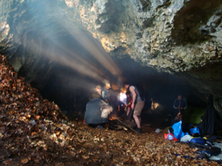
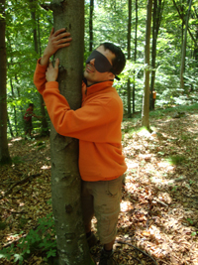
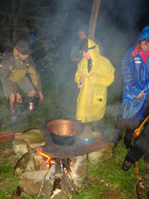

Youth4youth is looking for 8 partner organizations that would like to take part in the “Outdoor as a tool” training course on outdoor methods for inclusion, that will take part in 2015.

The exact date isn’t decided yet, but will be in probable in August, September 2015.

Place: Italy.

Program: see attachment

Introduction
The practice of outdoor education has been an active part of non-formal education for years, and due to it’s interactive character it has experienced many stages of development: both in theoretical, conceptual, pedagogical, practical and case-to-case ways. The term ‘outdoor education’ has been defined and used in many ways. Some time ago outdoor education was used as a synonymous with environmental education and outdoor recreation. The term, however, has transformed itself from environmental education to broader meanings and now it is frequently applied to programs or activities that can be, and usually are, conducted in the out-of-doors, and implying an interaction between the participant and the outdoor environment.

The general essential characteristics of outdoor education nevertheless have stayed the same. It occurs in the out-of doors, it has its participants directly involved in the activity, it involves the interpretation of original objects, it defines relationships rather than reciting individual, apparently isolated facts, it involves as many senses as possible and it invites participation because activity is perceived as being interesting, challenging and/ or even fun. So, outdoor education activities now seek to develop values relating to group work (in-group versus out-group), leadership and self-esteem.

This training course is designed aiming at quality and applicability of experiential learning methods of outdoor education, with a perspective on improving and including those groups of youth that are faced with social exclusion for numerous reasons (cultural background, sexual orientation, socio-economical position, etc.).

Aims and Objectives
Improving quality of inclusive youth work by rising trainers’ competences and youth workers to use and know the limitations of outdoor education and experiential learning methods, as renewed ways to reach a more diverse group of youth.

The objectives below make this aim more specific:
- Giving the target group tools to deal with quality experiential learning in outdoor education.
- Exchanging and sharing experiences, concepts and methods of outdoor education and experiential learning.
- Exploring ways to incorporate diversity management into the work and trainings the participants do.
- Developing cross-cultural awareness by providing structured space for sharing, experiencing and addressing intercultural learning.
- Increasing knowledge of the theoretical and pedagogical background of outdoor education and experiential learning methods.
- Developing teamwork, leadership and cooperation skills of the participants.
- Raising ability to transfer outdoor education and experiential learning concepts into day-to-day youth work practice.
- Setting basis for positive future cooperation within the Youth in Action program.

Participants
We aim for 27 participants from the 9 partner countries which will be involved in the whole training. This means that if you will be a partner (depending on how many interested organizations we will get, we will do a selection), you can select and send 3 participants to the training course in 2015.

Profile of participants
The target group of this training course is composed of youth workers and trainers who are directly working with young people from excluded groups and/or are from these groups themselves. They should have some experience in the training field, as we want them to be able to multiply as effective as possible after the training. Moreover they should have a strong interest in outdoor education, experiential methodologies and be willing to use it in their future youth work.

In case you are interested to participate in this outdoor training course, you should be aware that the training will follow the methodology of “learning by doing” and that means that some parts might be described as physically tough.

Furthermore, participants should:
- Be aged between 18 and 35
- Be in good physical shape
- Be working on a local or regional level with socially excluded youth
- Have proven personal and organisational interest in this training
- Be willing to continue cooperation after the training
- Be fully available during the whole training course (meaning 8 days and travel) and willing to participate actively
- Coming from Italy and 8 other partners.

Organisers
This training course is Youth4youth (Italy) – www.youth4youth.it

Travel, finances and accommodation
This training will go through a deadline of the Erasmus+ of the European Commission. When the training will be granted, the following issues will be subsidised:
- Travel costs: according to travel distance calculator
- Food and Accommodation of the training
- Materials-, organization- and training costs.

A participation fee for this training course will be asked of 50 euro per person (this cost will be deducted from your travel costs).

How to apply
Send the attached form by email and post to Youth4youth Email: Monica MANO, info@youth4youth.it

Deadline for applying
Since the deadline for applications to the Erasmus+ is the 4th of February, we need your information and PIC number by the 25th January.

